**CIED Information System User Guidance**

1. Overview

CIED follow-up through telemonitoring offered today by many main CIED vendors, is gradually being adopted in the practice of cardiovascular treatment. The sharing of updated reports and parameter assessment as offered by the data servers and networks connections implemented by many vendors, is helpful for healthcare providers to gain a better understanding of the progress in rehabilitation and the overall effects of medical treatment. Furthermore, emergency alarms and potential problems can be reported and addressed immediately.

In the iCARDEA project, CIED Information Integration System employs standards specifications from ISO/IEEE 11073 (Health Informatics, Point-of-care Medical Device Communication) and HL7v2.x in the context of Integrating the Healthcare Enterprise (IHE) profiles to deliver telemonitoring CIED report data from two different CIED vendors (Medtronic and St. Jude Medical) to the adaptive care planner that implements guideline-driven care plans. And this software component will be practically implemented in the SALK with other interacted software components. This paper shows the basic implementation and operation procedure as well as some notices for the direct user and administer.

2. CIED Data Integration with CIED Vendor data server.

2.1 Medtronic CareLink® platform

Medtronic current system for CIEDs and patient follow-up is based on two approaches:

**1. Traditional manual interrogation of the devices in clinic during the patient visit to the electrophysiologist**

In this approach, the devices are revised during the consult visits and the device information can be checked by the specialist through the programmer. (The CIED report for the clinical follow-up will be saved in the CIED device and interrogated in the next remote follow-up)

**2. Remote monitoring using the CareLink® platform**

In this approach, the devices are interrogated automatically or manually. The interrogations may be programmed or can be triggered under demand if the patients or the specialists require it. The information is presented to the professionals through the web based CareLink application or the CSG (Connected System Gateway), Medtronic software application that resides on a secure clinic provided system and enables automatic routing of reports from the CareLink Website to a file system located on a clinic’s local network. Reports are exported from CareLink and stored in file system on clinic’s local network, with a unique filename. Clinic can manually attach them to the patient record or can write custom code to attach them to the patient record.#

Depending on the model of the device implanted, the patient will need to carry out the interrogation manually with the CareLink Monitor Antenna or it will be automatically done wirelessly through the Connexus Wireless Monitor.



Figure 1. Remote monitoring using the CareLink® platform

**Note: CIED Information System is only responsible for the CIED PDF report which is supplied by CareLink® platform.**

2.2 St. Jude Medical Merlin.net™

The Merlin.net™ Patient Care Network (PCN) allows integration of essential device data with electronic health records for timely, convenient access to key information that can help optimize clinic resources and streamline patient care. Examples are EHR systems by GEMMS or LUMEDX, or any other system that can process implantable device data delivered as HL7 V2.5 ORU message.

Wireless transmission of industry-standard information from St. Jude Medical pacemakers, ICDs and heart failure devices can be integrated with individual electronic health records (EHR) and is designed to provide a single point of access to pertinent information that can lead to earlier intervention and enhanced patient care.

Disease management functions available in St. Jude Medical wireless ICDs and pacemakers are remotely accessible on Merlin.net PCN: Wireless functionality allows clinics to benefit from efficiencies gained through wireless implants, follow-ups and daily remote monitoring. A complete device and disease diagnostic is possible via the remote monitoring system as the entire diagnostic memory content of the device is transferred and presented in PDF report format.

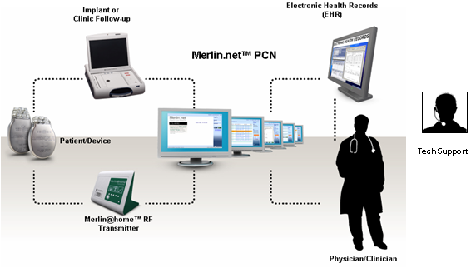

Figure 2. Remote monitoring using the Merlin.Net® platform

**3. CIED Data Integration**

**3.1 CIED data integration with** **CareLink**

**3.1.1 Retrieve Medtronic CIED PDF report through CSG**

**Note: The information in this section please check document “2010-05-28-SRFG_iCardea_D911_v10e_part1.doc”**

**Note: Currently CSG is not implemented in the SALK server or PDF file transmission to defined local directory is permitted by local firewall. If CSG could not implemented and run as expect, please down the PDF report from CareLink webpage manually.**

**3.1.2 Retrieve Medtronic CIED PDF report through CareLink Webpage**

In additional to get CIED PDF files from CSG automatically, user could also download the CIED PDF files from CareLink web manually without CSG.

1. Users export a report from the Transmissions > Active Transmissions tab

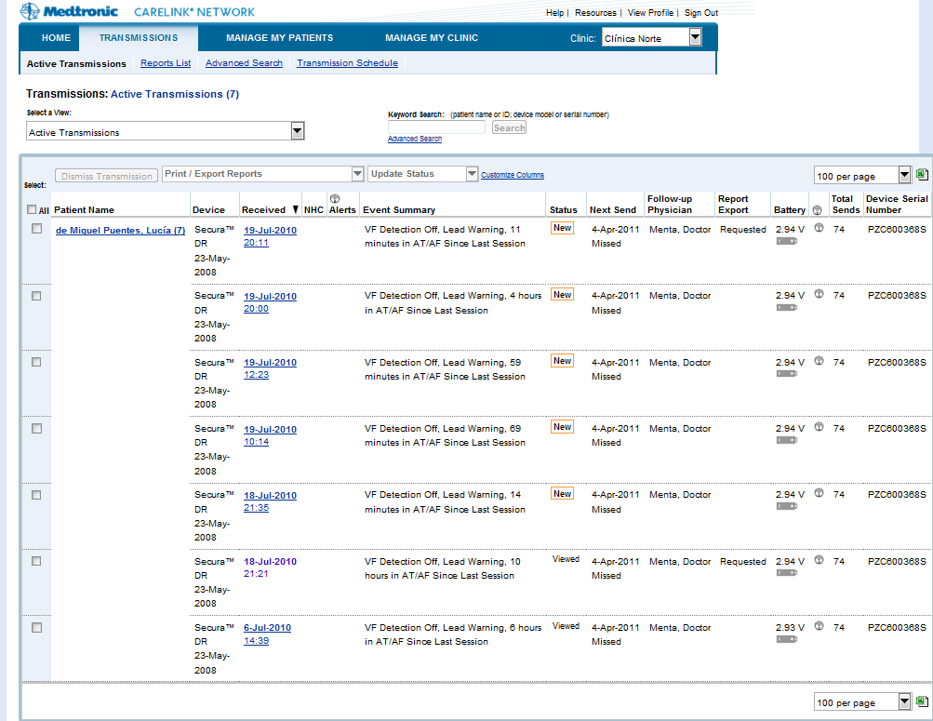

2. Click drop down list “Print/Export Report”

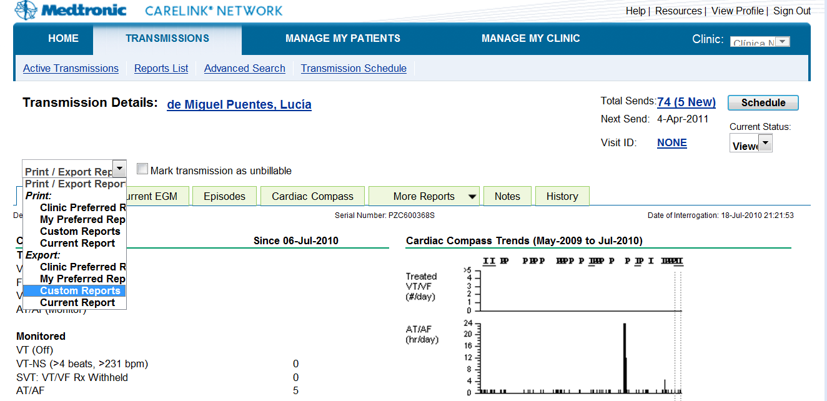

3. In the “Request Custom Reports” Choose check box “Select:” with “All”. Then click “submit” at the bottom of the webpage.

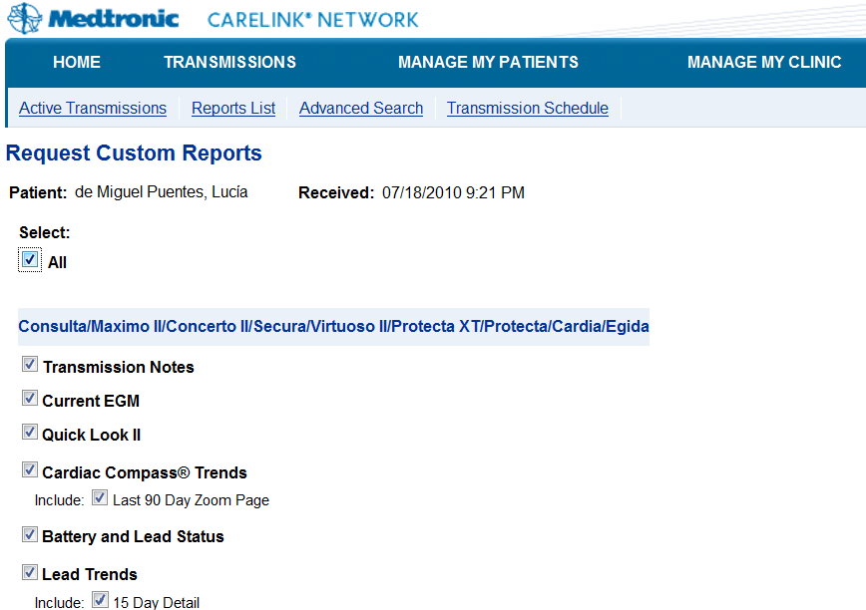

4. Under “Transmission” webpage, “Report List” Click “Available to print” and webpage with PDF will appear.

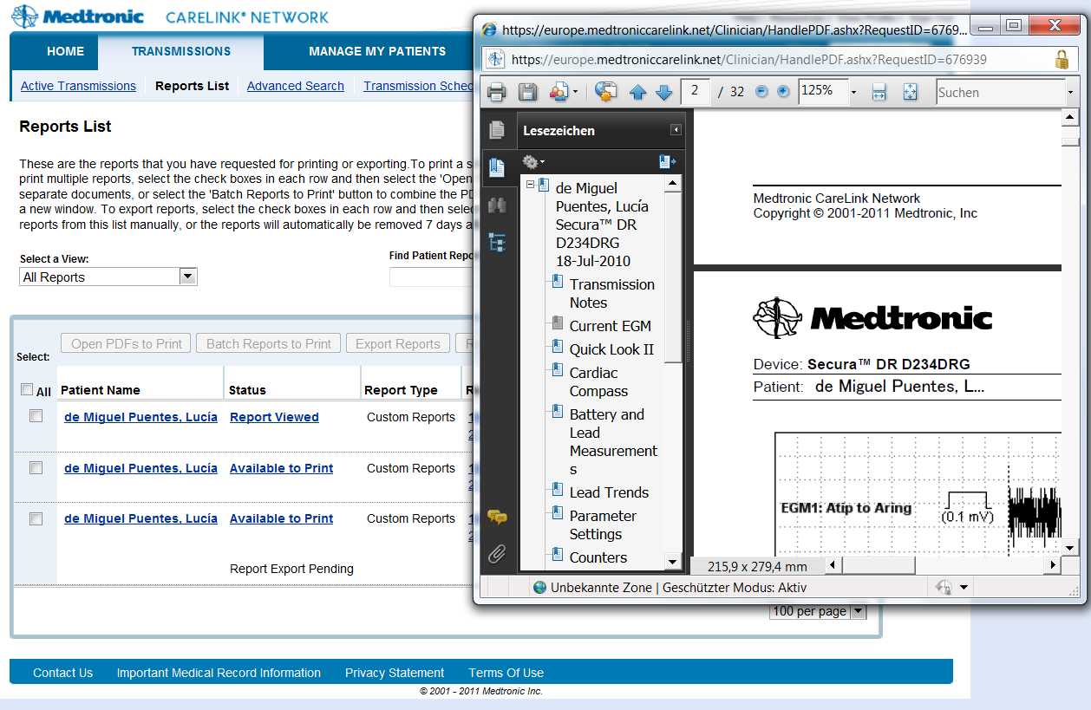

5. Save the PDF files with individual filename in the directory which is indicated by ***DIRECTORY_MEDTRONIC_ORIGINAL_PDF_REPORT*** in configuration file AppConfig.properties. For example: ***C:\\Test\\Medtronic\\unprocessed\\***

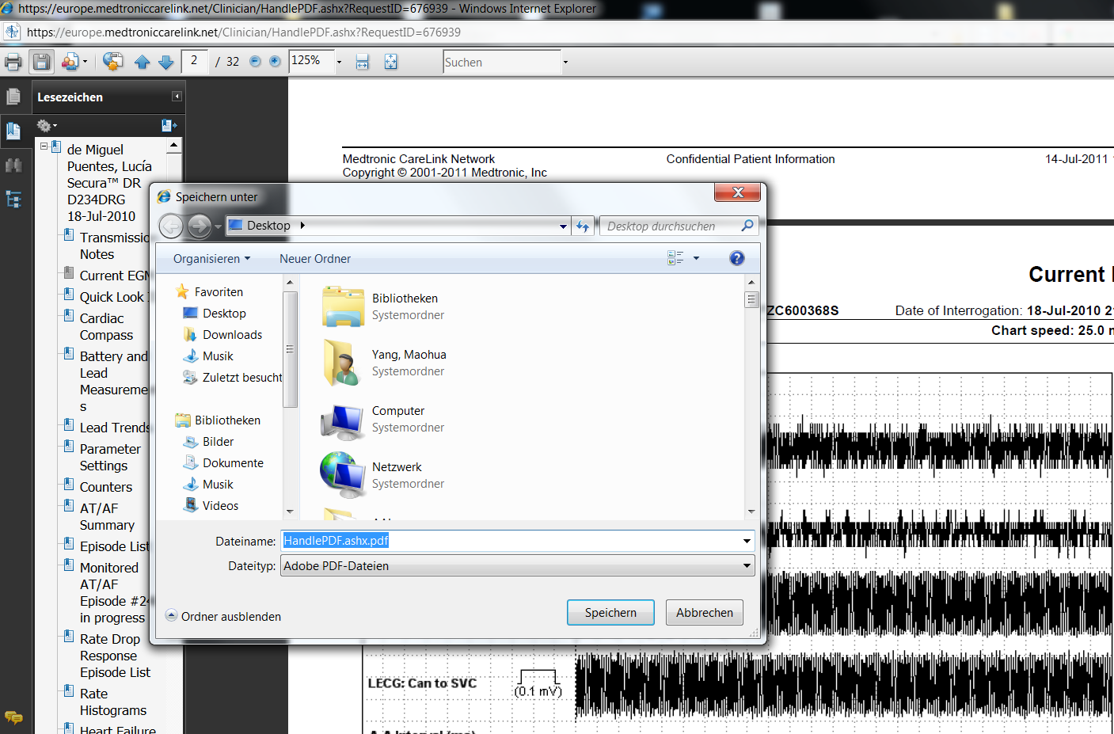

**Note: Currently CIED Data Integration Module is only competent for PDF report in English language. Please generate PDF files from CareLink in English form.**

**3.2 CIED data integration with Merlin.net**

**Note: The information for this section is from iCARDEA document “2010-05-28-SRFG_iCardea_D911_v10e_part2.doc”**

EHR Export set-up configuration and export triggering within Merlin.net are depicted in figure as below:

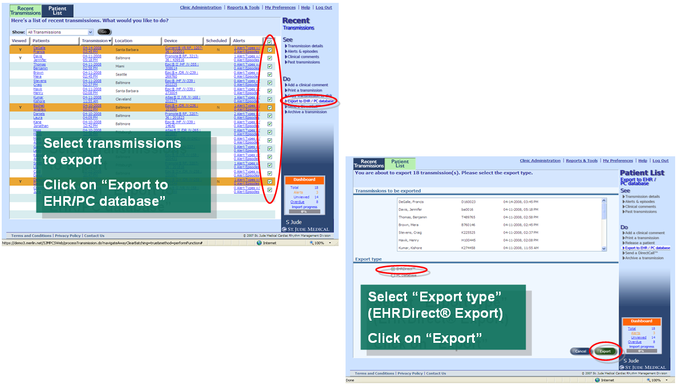

Figure 3 EHR Export triggering within Merlin.net

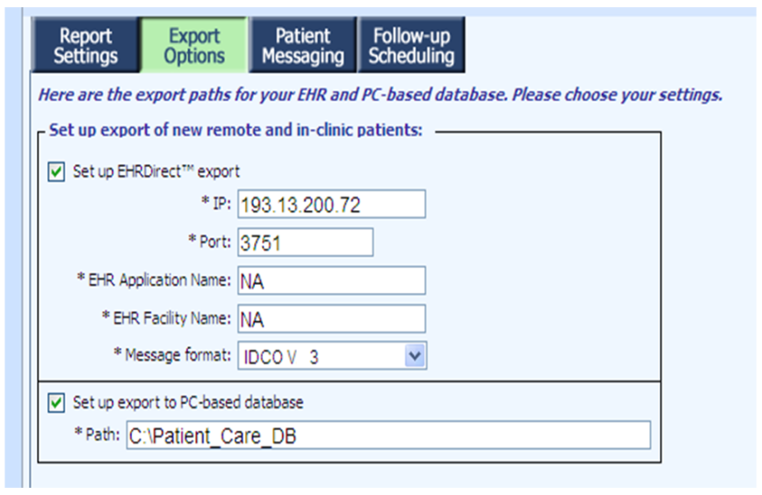

Figure 4 EHR Export Set-up

Export Options

-Check Box: Set up EHRDirect export

*IP: the iCARDEA server IP address

*Port: the defined Port number for the iCARDEA CIED Data Integration. This should be same as parameter ***SJM_CLIENT_GENERIC_PORT*** defined value.

*Message format: Select IDCO V2 (The expected CIED message is in HL7v2.5 format)

CIED Data Integration Module will monitor the IP address and port number as a client for the receiving HL7v2 Message from Merlin.Net. The received HL7v2 Message will be saved in the directory defined by parameter ***DIRECTORY_ORIGINAL_HL7_MESSAGE.***

**Note: Please make notice that whether the data transmission of HL7 message to defined IP address and Port number is permitted by local firewall.**

**4. CIED Information System Configuration**

**4.1 Configuration HL7 Sending for Adaptive Care Planner.**

SEND_TO_CARE_PLANNER=Yes

-Sending to Adaptive Care Planner (Yes/No)

ENCAPSULATED_BASE64_EGM_PDF=NO

-Whether integrate Base64 coded EGM PDF files into HL7 message OBX-Segment (Currently ‘No’)

# LOCAL PARSING defines the format of the file based HL7 Messages

LOCAL_HL7_FILEFORMAT_inXML=No

-Store HL7v2.5 (received from Merlin.Net and parsed by PDF from CareLink) in *.xml or *.hl7 format

ADAPTIVE_CARE_PLANNER_HL7_SERVER=localhost

-The IP address for Adaptive Care Planner

ADAPTIVE_CARE_PLANNER_HL7_PORT=21012

-The port number for Adaptive Care Planner

# definition of the accepted format of the MLLP Server

ADAPTIVE_CARE_PLANNER_HL7_isXML=Yes

-Sending HL7v2.5 to Adaptive Care Planner in *.xml or *.hl7 format.

**4.2. Configuration for the HL7 Receiver (Client for Merlin.net).**

#The Port for the HL7 message which is transmitted from Merlin.Net

SJM_CLIENT_GENERIC_PORT=21014

-Port number which is specified for receiving HL7 message from Merlin.Net

**4.3. Configuration for directory**

# The directory for the original CIED PDF files from Medtronic CareLink

DIRECTORY_MEDTRONIC_ORIGINAL_PDF_REPORT=C:\\Test\\Medtronic\\unprocessed\\

-Story the CIED PDF files from CareLink in this directory, and these PDF will be parsed to HL7v2.5 ORU message.

# The directory for the CIED PDF files which has been parsed to HL7 file successfully

DIRECTORY_MEDTRONIC_PROCESSED_PDF_REPORT=C:\\Test\\Medtronic\\processed\\

-After parsing, successfully processed CIED PDF files will be moved into this directory.

# The directory for the CIED PDF files which could not be parsed

DIRECTORY_MEDTRONIC_UNKNOWN_PDF_REPORT=C:\\Test\\Medtronic\\unknown\\

-After parsing, unrecognized PDF files (wrong format, broken file or lacing obligated contents) will be moved into this directory.

# The directory for the EGM PDF files which will be integrated in HL7 OBX-Segment with Base64 Code

DIRECTORY_MEDTRONIC_EXPORTED_EGM=C:\\Test\\Medtronic\\tmp_exported_EGM\\

-During parsing process, required EGM figures will be abstracted and reconverted into a new PDF files and stored in this directory for Base64 coded integration.

# The input directory for HL7 Message which will be processed by the PIX Module

# Currently the Medtronic PDF file parsed and transformed to HL7 message

# and the received St. Jude Medical HL7 message will be stored here

DIRECTORY_ORIGINAL_HL7_MESSAGE=C:\\Test\\hl72pix\\

-HL7 parsed by CareLink PDF files and received from Merlin.Net will be stored in this directory for PIX integration processing.

# The output directory for HL7 message after PIX integration processing

# Currently the HL7 Sender module uses this as input dir. for the outgoing transmission

DIRECTORY_PIX_HL7_MESSAGE=C:\\Test\\hl7withpix\\

-After PIX integration processing, new HL7 with Patient Identify will be stored in this directory for transmission to Adaptive Care Planner.

# The directory for HL7 messages which have been successfully transmitted through MLLP and TCP

DIRECTORY_HL7_TRANSMITTED=C:\\Test\\hl7_transmitted\\

-Successful transmitted HL7 message wil be stored in this directory.

**Appendix A: Flow chart for the data processing**

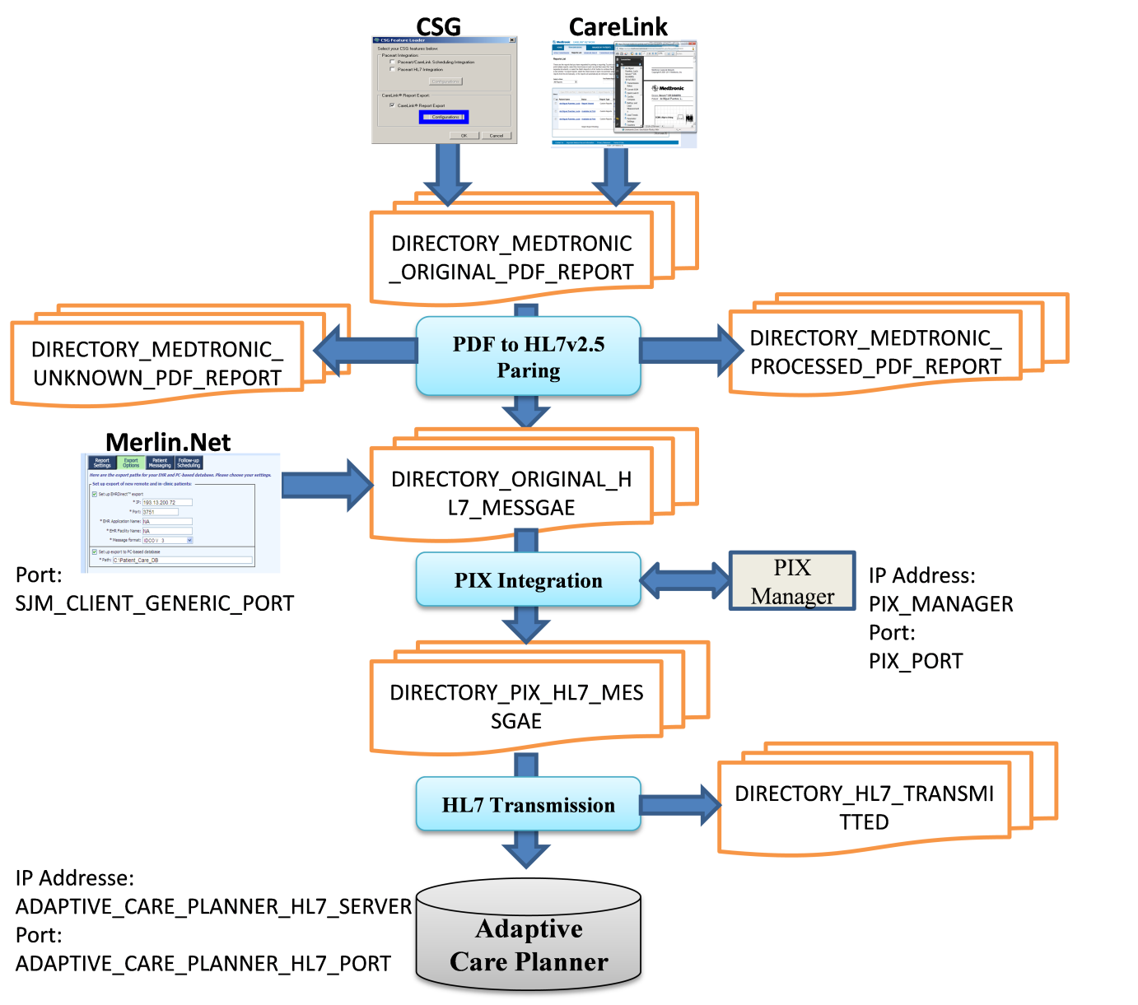

Figure 5. Flow chart for the data processing

All parameters have been defined in configuration file:Appconfig.properity. User please reconfigure all parameters conform to own practical implementation.

1. PDF report from Medtronic will be downloaded by CSG automatically or through Webpage manually into directory: ***DIRECTORY_MEDTRONIC_ORIGINAL_PDF_REPORT***

**Note: If PDF files could not be transmitted into *DIRECTORY_ORIGINAL_HL7_MESSAGE* through CGS or download by CareLink webpage directly because of firewall or any other reasons, please get PDF files outside the firewall and copy past received PDF files into *DIRECTORY_ORIGINAL_HL7_MESSAGE***

2. PDF report will be parsed and generated HL7 messages will be stored in directory: ***DIRECTORY_ORIGINAL_HL7_MESSAGE.*** The successfully parsed PDF files will be moved into directory ***DIRECTORY_MEDTRONIC_PROCESSED_PDF_REPORT.*** And the unrecognized PDF files will be moved to directory ***DIRECTORY_MEDTRONIC_UNKNOWN_PDF_REPORT.***

3. HL7 message from Merlin.Net will be transmitted to through server IP address and port number same as ***SJM_CLIENT_GENERIC_PORT*** into directory: ***DIRECTORY_ORIGINAL_HL7_MESSAGE***

**Note: If HL7 files could not be transmitted into *DIRECTORY_ORIGINAL_HL7_MESSAGE* through Merlin.Net directly because of firewall or any other reasons, please get the HL7 files outside the firewall then copy the received HL7 files and past into *DIRECTORY_ORIGINAL_HL7_MESSAGE***

4. HL7 files parsed by PDF from CareLink and from Merlin.Net will be processed through PIX Integration. And the processed HL7 files integrated with Patient identify will be stored in directory: ***DIRECTORY_PIX_HL7_MESSAGE***

5. All HL7 files with patient identify will be transmitted to Adaptive Care Planner through IP address***: ADAPTIVE_CARE_PLANNER_HL7_SERVER*** and port number ***ADAPTIVE_CARE_PLANNER_HL7_PORT*** in format ***ADAPTIVE_CARE_PLANNER_HL7_isXML***

6. Successfully transmitted HL7 files will be moved into directory ***DIRECTORY_HL7_TRANSMITTED***

**Appendix B. Tips for the user**

The notes for the user and administer in SALK

1. Please use IE Web Browser to retrieve CIED PDF and HL7 report from CareLink and Merlin.Net (CareLink and Merlin.Net could only be operated through IE Version)

2. Currently all PDF report in SALK should be shown only in English form. The function for multi languages will be realized in next updated version if any other language requirement is needed.

3. Is there any firewall limitation for the PDF report downloading by CSG and HL7 messages transformation through Merlin.Net? If there is any problem caused by firewall, please inform OFFIS team and the possible suggested solution is UMTS USB disk.

**Appendix: C Appconfig.properity**

####################################################

# #

# D A T A B A S E - S E T U P #

# #

####################################################

# DB url (JDBC connection string)

# A complete list of H2 URL parameters can be found here:

# http://www.h2database.com/html/features.html#database_url

#

# For H2 these optional URL parameters may be required:

# a) ";IFEXISTS=TRUE" should be added once the DB exists to prevent creating a new database file

# b) For SSL "jdbc:h2:ssl://<server>[:<port>]/<databaseName>"

# c) For AES encryption use ";CIPHER=AES" or for XTEA use ";CIPHER=XTEA"

# d) To prevent automatic closing of the DB after the last client logs out use ";DB_CLOSE_ON_EXIT=FALSE"

# CIPHER=AES

DB_CONNECTION_STRING=jdbc:h2:tcp://127.0.0.1/cieddb

# DB user

DB_CONNECTION_USER=sa

# DB password

DB_CONNECTION_PW=

# DB connection pool driver class name

# Examples:

# ---------

# PostgreSQL: org.postgresql.jdbc3.Jdbc3PoolingDataSource

# MySQL.....: com.mysql.jdbc.jdbc2.optional.MysqlConnectionPoolDataSource

# H2........: org.h2.jdbcx.JdbcDataSource

DB_CONNECTIONPOOL_DRIVERCLASS=org.h2.jdbcx.JdbcDataSource

# DB DataSource name

DB_CONNECTIONPOOL_DATASOURCENAME=cieddbds

# DB driver type (if supported). Normally it is empty but for Oracle it has to be 'thin'.

DB_CONNECTIONPOOL_DRIVERTYPE=

# DB server name or IP-Address

DB_CONNECTIONPOOL_SERVERNAME=127.0.0.1

# DB port number (if empty/not set the default port of the DB is used but a warning is written to the logfile)

DB_CONNECTIONPOOL_SERVERPORT=

# DB database name (where the tables will be found; if supported)

DB_CONNECTIONPOOL_DATABASENAME=cieddb

# Minimum (initial) number of DB connections for the connection pool (if supported).

DB_CONNECTIONPOOL_MINCONNECTIONS=5

# Maximum number of DB connections the connection pool can open.

DB_CONNECTIONPOOL_MAXCONNECTIONS=10

####################################################

# #

# D I R E C T O R Y S C A N N E R - S E T U P #

# #

####################################################

# The unit to be used for the scan interval time.

# This can be 'seconds' (default), 'minutes' or 'hours'. The case is ignored.

DIRECTORYSCANNER_SCAN_INTERVAL_UNIT=seconds

# The directory scan interval time (pause time between scans).

DIRECTORYSCANNER_SCAN_INTERVAL_TIME=10

# The list of directories to scan. Each directory entry is separated by a '#' character from the next entry.

# The directory for the original CIED PDF files from Medtronic CareLink

DIRECTORY_MEDTRONIC_ORIGINAL_PDF_REPORT=C:\\Dokumente und Einstellungen\\dvxxx\\Eigene Dateien\\medtronic_pdf\\

# The directory for the CIED PDF files which has been parsed to HL7 file successfully

DIRECTORY_MEDTRONIC_PROCESSED_PDF_REPORT=d:\\OFFIS\\data\\Medtronic\\processed\\

# The directory for the CIED PDF files which could not be parsed

DIRECTORY_MEDTRONIC_UNKNOWN_PDF_REPORT=d:\\OFFIS\\data\\Medtronic\\unknown\\

# The directory for the EGM PDF files which will be integrated in HL7 OBX-Segment with Base64 Code

DIRECTORY_MEDTRONIC_EXPORTED_EGM=d:\\OFFIS\\data\\Medtronic\\tmp_exported_EGM\\

# The input directory for HL7 Message which will be processed by the PIX Module

# Currently the Medtronic PDF file parsed and transformed to HL7 message

# and the received St. Jude Medical HL7 message will be stored here

DIRECTORY_ORIGINAL_HL7_MESSAGE=d:\\OFFIS\\data\\hl72pix\\

# The output directory for HL7 message after PIX integration processing

# Currently the HL7 Sender module uses this as input dir. for the outgoing transmission

DIRECTORY_PIX_HL7_MESSAGE=d:\\OFFIS\\data\\hl7withpix\\

# The directory for HL7 messages which have been successfully transmitted through MLLP and TCP

DIRECTORY_HL7_TRANSMITTED=d:\\OFFIS\\data\\hl7_transmitted\\

# The directory for received HL7 messages (only for testing)

DIRECTORY_HL7_RECEIVED=d:\\OFFIS\\data\\hl7_careplanner_received\\

####################################################

# #

# P D F - P A R S E R - S E T U P #

# #

####################################################

# The language setting for the PDFParser. It identifies the specialized

# property file read by the parser.

# This is the two letter ISO 639-1 language code e.g. 'en' (default), 'de', etc. The case is ignored.

PDFPARSER_LANGUAGE_SETTING=en

PDFPARSER_SUPPORTED_ICD_TYPE=Consulta|Maximo II|Concerto II|Secura|Virtuoso II|Protecta XT|Protecta|Concerto|Reveal

####################################################

# #

# A D A P T I V E C A R E P L A N N E R #

# S E T U P #

# #

####################################################

# if we say no, we start an local server to receive the messages,

# for demo and testing purpose

SEND_TO_CAREPLANNER=No

ENCAPSULATED_BASE64_EGM_PDF=NO

#Encapsulated_Base64_EGM_PDF_File=No

# LOCAL PARSING defines the format of the file based HL7 Messages

LOCAL_HL7_FILEFORMAT_inXML=No

ADAPTIVE_CARE_PLANNER_HL7_SERVER=localhost

ADAPTIVE_CARE_PLANNER_HL7_PORT=21012

# definition of the accepted format of the MLLP Server

ADAPTIVE_CARE_PLANNER_HL7_isXML=Yes

####################################################

# #

# HL7 Receiver #

# S E T U P #

# #

####################################################

HL7_RECEIVER_PIPE_PORT=21011

HL7_RECEIVER_XML_PORT=21012

HL7_RECEIVER_GENERIC_PORT=21013

SJM_CLIENT_GENERIC_PORT=21014

####################################################

# #

# PIX Manager #

# S E T U P #

# #

####################################################

PIX_MANAGER=localhost

PIX_PORT=2575